**A Modeling and Experimental Investigation on the Formation of Acicular Silicon and Sludge in High Pressure Die Casting of a Modified A383 Alloy**

Mikko Kärkkäinen1, Tao Liu 1, Laurentiu Nastac1, Luke Brewer1, Vishweshwar Arvikar2 and Ilya Levin2

1The University of Alabama, Department of Metallurgical and Materials Engineering, Box 870202, Tuscaloosa, Al, 35487, USA

2Nemak Alabama, USA

**Abstract**

A numerical model is being developed to predict the formation of sludge (e.g., Fe-containing intermetallic compounds) and acicular silicon during high pressure die casting (HPDC) of a modified aluminium A383 alloy. The iron-rich sludge-phase and silicon rich phases with needle-like morphology play a major detrimental role in the mechanical properties, especially the fracture characteristics, of h pe and size of detrimental phases) in A383 samples extracted from various regions of an HPDC engine block. The approach can be applied to predict the effects of cooling rate on the final phase microstructure.

**Introduction**

Iron-rich intermetallics, especially the $β$- phase, has been shown to have a deleterious effect on mechanical properties in aluminium casting.1,2 Also, the shape and size of silicon rich phases has been shown to have a significant effect on the elongation of aluminum alloys 3,4. These phases are of interest when optimising any aluminum casting process.

The objective of this work is to apply a transient modeling approach to get insights into the effects of cooling rate on the solidification structure of HPDC A383 alloy. The strategy consists of comparing cooling rates simulated by a commercial transient macroscopic model (**NovaFlow & Solid CV** by Novacast ([www.Novacast.se](http://www.Novacast.se)) with experimentally measured phase fractions, phase sizes and types. The results can assist in achieving better control of the solidification structure and mechanical properties in the final cast product. A schematic of the HPDC process and the simulation is illustrated in Figure 1.

**Simulation methods**

**NovaFlow & Solid CV** is a commercial mold filling and solidification simulation software developed by NovaCast Systems AB. The software uses a Gauss-Seidel solver with a control volume mesh to solve heat, mass transfer and Navier-Stokes equations as well as free surface fluid flow in 3D via volume of fluid (VOF) method.

C:\Users\Nastac\Desktop\Article pictures\Figures\Figure 1\Figure 1.tif

Fig. 1. Diagram of HPDC process and simulation geometry

The current simulation of the HPDC A383 process used a quasi-equilibrium solidification model with the assumption of no convective heat or mass transfer inside the melt. No segregation was assumed to occur either. A convective cooling heat transfer boundary condition was assumed at the water channel – casting boundary and the mold-air boundary. The main process parameters used in the simulation are summarised in Table 1. The parameters are typical for an HPDC process.

All thermal properties for the A383 alloy and the die material H13 used in the simulation were a function of temperature. A modified phase diagram approach is used by **NovaFlow &Solid** **CV** to account for the multicomponent melt chemistry and to model the evolution of the liquid and solidification phases (primary and eutectic) in A383. The geometry of the mesh was 555 x 1080 x 1255 mm, with a cell size of 5 mm. The melt chemistry of the A383 alloy used for the simulation is shown in Table 2.

Table 1. Process parameters

|  |  |
| --- | --- |
| Initial temperature | 630 $℃$ |
| Filling time | 125 ms |
| Mold thickness | 25 mm |
| Average die temperature | 300 $℃$ |
| Cooling water temperature | 20 $℃$ |
| Air temperature inside the mold | 45 $℃$ |
| Cavity pressure | 82.5 MPa |

Table 2. Simulated melt composition, (wt. %)

|  |  |  |  |  |  |  |  |  |
| --- | --- | --- | --- | --- | --- | --- | --- | --- |
| **Al** | **Si** | **Cu** | **Zn** | **Mn** | **Ni** | **Sn** | **Mg** | **Fe** |
| 83.45 | 10.5 | 2.5 | 1.5 | 0.5 | 0.3 | 0.15 | 0.1 | 1.0 |

**Experimental Procedure**

The A383 cast alloys were made by the High Pressure Die Casting (HPDC) process at **Nemak** **Alabama**. Samples were cut from the casting locations with different solidification times according to the results of simulation. Samples used for optical microscopy were made by metallographic techniques with diamond suspension in 9 µm, 3 µm, and 1 µm. The microstructure was analysed using a **Nikon Epiphot 200** microscope. The characteristics of sludge and eutectic Si particles, including area and roundness, were measured and quantified using **Photoshop CS6** in conjunction with the optical micrographs. For each sample, at least 3 fields of view at a magnification of 500X were examined from different parts of the sample surface. An energy dispersive x-ray spectroscopy (EDS) analysis of the sludge phase composition was performed using a JEOL 7000 scanning electron microscope (SEM) with an Oxford Instruments EDS detector system.

C:\Users\Nastac\Desktop\Article pictures\Figures\Figure 2\Figure 2.tif

Fig. 2 Location of samples. Samples 1, 2, 3 are the front, rear and center surfaces of the block extracted from the locations shown.

**Results and Discussion**

Figure 3 shows the simulated local solidification time for the cross section used in the measurements. Local solidification time is given by the time required for the point to cool from liquidus to solidus temperature. The figure also has zoomed in view of the location of samples 1, 2 and 3 from a perpendicular axis, plotting the solidification time of these samples. The pictures in Fig. 3 show that solidification time is the shortest at the top of the cylinders, which are the furthest points from feeding.

The local solidification time in these locations is shorter than 1 second. The cylinder walls also rapidly solidify, in the range of 2-10 seconds. This is explained by the cylinder having a large ratio of area of contact over volume with the mold and an adjacent cast iron “sleeve”. The bulkhead, the arc-like geometry below the cylinders, has a solidification time in the range of 30-40 seconds, which is approximately the same duration as the time the A383 alloy is held inside the mold during the HPDC process. The path along the main feeding vein of the castings has the longest solidification time, 60-80 seconds. However in practice, the cooling time may be slightly different, since the casting is removed from the mold at approximately 30-45 seconds after filling and exposed to air cooling, and these steps were not simulated.

The current simulated solidification times do not directly account for “cycling”, *i.e.*, the repeated casting of multiple engine blocks in the same mold, which may introduce variation in the mold surface temperature boundary condition. Instead the average temperature of the mold over multiple cycles was used. According to the simulation, the effect of water cooling channels in the casting appears to be highly localised to the inner surface of the channels, and marginal in effect elsewhere.

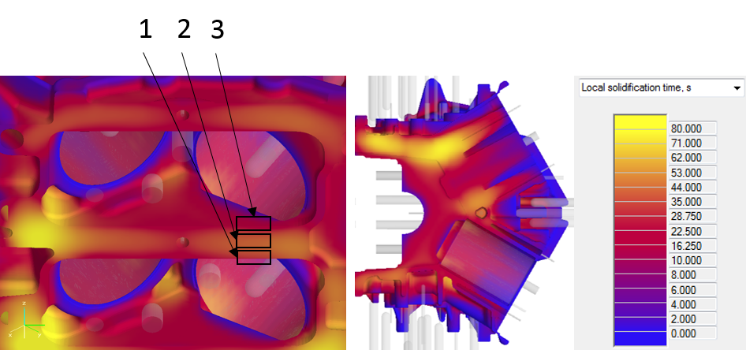

Fig. 3 Local solidification time (in seconds) profile in the A383 casting. Cross-section of casting with close-up of sample 1, 2 and 3 shown on the left.

Figure 4 shows the inverse cooling rate for samples 1, 2 and 3. The cooling rates of the samples coincide with the local solidification time. It can be seen that the cooling rates of the bulkhead outer surfaces, where samples 1 and 3 were taken, are not symmetrical. Sample 1 has a lower cooling rate than sample 3 due to the flow pattern of the filling. Figure 5 shows the simulated inverse cooling rates of samples 4 and 5. Sample 4, located at the most remote location, the rim circling the right cylinder, actually has a lower cooling rate than the inner cylinder surface where sample 5 was taken. This may be explained by the pattern of flow during filling. The calculated cooling rates for all of the samples are shown in Table 3.

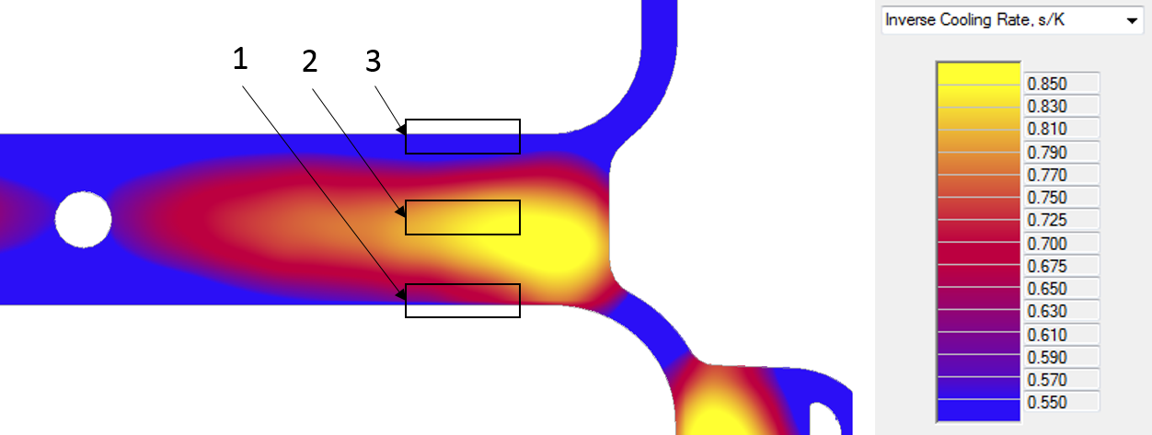

Fig .4 Inverse cooling rate of the samples 1, 2 and 3, (s/K)

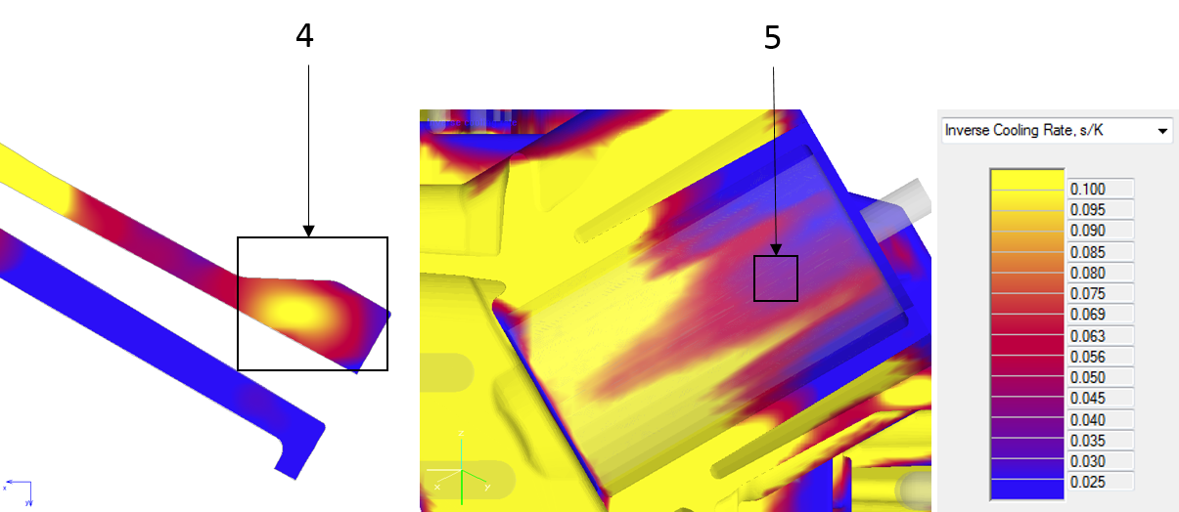

Fig. 5 Inverse cooling rate of the samples 4 and 5, (s/K)

Table 3. Cooling rates of the samples

|  |  |
| --- | --- |
| **Sample** | **Cooling rate, K/s** |
| 1 | 1.7 |
| 2 | 1.2 |
| 3 | 2.8 |
| 4 | 10 |
| 5 | 25 |

Figure 6 shows micrographs used for the silicon size and roundness analysis. Samples taken close to the metal-mold interface, coinciding with a high cooling rate (Fig. 6a), have a fine eutectic structure. The silicon morphology is globular and the area is small. Samples taken from lower cooling rate areas (Fig. 6b) show an acicular or plate-like morphology, and significantly increased size. According to previous experimental work, large elongated needle-like silicon particles are especially harmful for the ductility of the alloy. This figure also shows larger dark grey plate-like features. These are sludge particles, iron-rich intermetallics. In the analysed samples, the sludge content was below 2 %. The approximate average composition of the sludge according to EDS-analysis is shown in table 4.

Table 4. Sludge composition (wt%)

|  |  |  |  |  |  |  |  |
| --- | --- | --- | --- | --- | --- | --- | --- |
| **Al** | **Si** | **Cu** | **Zn** | **Fe** | **Mn** | **Cr** | **Ni** |
| 58.46 | 11.21 | 1.85 | 0.71 | 18.15 | 7.14 | 2.29 | 0.28 |

Figure 7 shows the results of the quantitative analysis of eutectic silicon mean size and roundness. At least 3 micrographs were analysed for each sample and the average values are shown in Fig. 6. A roundness value of 1 indicates a spherical particle; while particles with a roundness value approaching zero are needle-like, or acicular, in appearance. There appears to be a logarithmic correlation between the mean particle size and cooling rate. Between the cooling rates 10 K/s and 25 K/s, a major shift occurs from coarse acicular structure to fine globular eutectic, which can be seen in the difference in roundness and size. Another large difference can be observed at cooling rates below 1 K/s, where the mean silicon size rapidly increases and the morphology becomes almost entirely acicular.

*C:\Users\Nastac\Desktop\Article pictures\Figures\Figure 5\Figure 5.tif*

Fig. 6 (a) Microstructure from metal-mold interface. Large plate-like dark grey features are sludge particles. Fine eutectic Al-Si structure in primary aluminum matrix (b) Microstructure from center of the casting, with acicular silicon, sludge particles, and coarse eutectic grains.

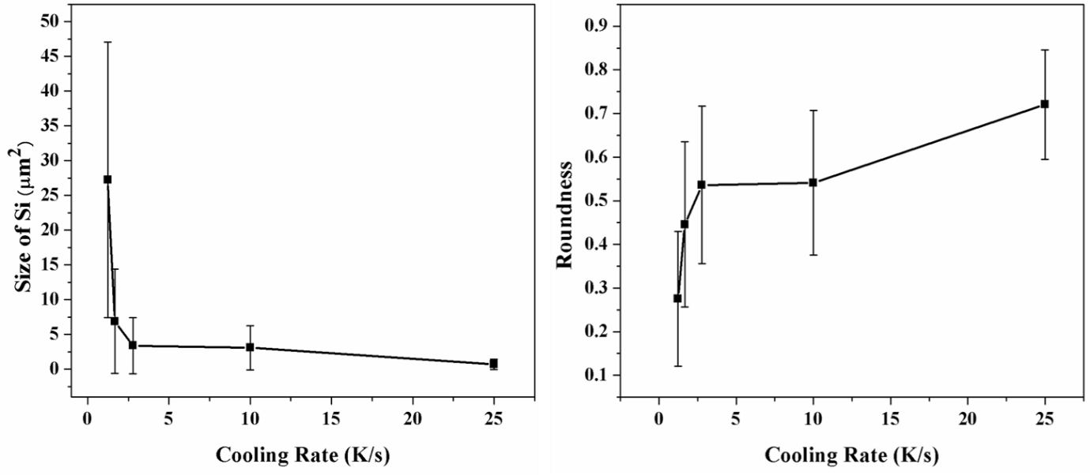

Fig. 7 Cooling rate versus silicon size and roundness

Figure 8 illustrates the size of the sludge particles and fraction of the sludge phase in the samples. The results show that the size of the sludge particles increases rapidly at below 2.5 K/s cooling rate, suggesting a different growth rate for the sludge. At cooling rates above 2.5 K/s, no difference is observed in mean sludge size. The fraction of sludge is higher by a factor of 2 in sample 2, taken from the center of the ‘bulkhead’ of the casting, than the other samples, which were taken close to the metal-mold interface. Again, cooling rate above 2.5 K/s was seen to have a negligible effect of the sludge fraction, as it did with the mean particle size.

There are multiple ways of formation and growth of the sludge phase. Uniformity of the sludge size and fraction would support the conclusion that sludge is formed before the casting, in the holding furnace or in shot sleeve, where it has time to grow uniformly before the HPDC casting process where large thermal gradients exist. However, the large mean size of sludge in the samples taken close to the center of the casting suggests that the sludge particles show major growth and/or coalescence during the solidification interval in the casting, which leads to another conclusion that sludge nucleation and growth can take place during casting as well. Further experiments and simulations are needed to verify the sludge formation timeframe and mechanism.

**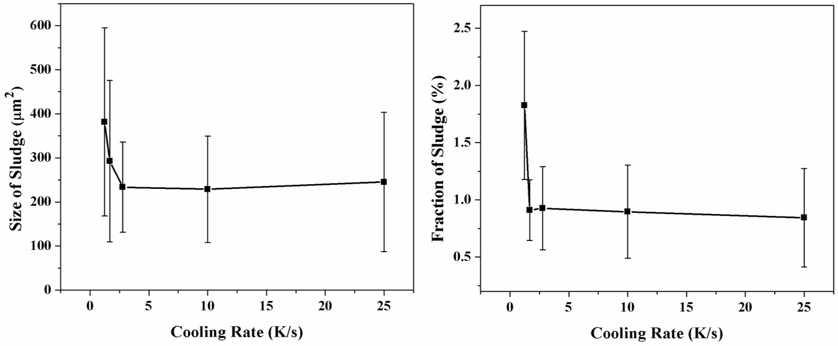****

Fig. 8 Mean size and area fraction of sludge particles as a function of cooling rate

**Conclusions**

The sludge particle size is relatively large at cooling rates below 2.5 K/s. At higher cooling rates, variance is negligible. Fewer sludge particles are found at the metal-mold interface, indicating less trapping of pre-existing sludge formed before the casting. Microstructure modelling and further experiments including differential scanning calorimetry (DSC) are needed to verify the sludge formation mechanism.

The size and roundness of eutectic silicon appear to have a logarithmic correlation with the simulated cooling rate. However, sample 4 is an outlier, and has coarser silicon particle size than the simulated cooling rate indicates. The current results suggest that local cooling rate is a key factor in determining the morphology of the eutectic, which, assuming no defects exist, to a large degree determines the mechanical properties of the casting.

The quasi-equilibrium solidification model appears to be on the right track for predicting solidification time of alloy in HPDC, since the eutectic silicon morphology has a good correlation with the simulated local solidification time. However, more experimental indicators for solidification time and cooling rate are needed for validation.

**References**

1. S. Ferraro. and G. Timelli,. Influence of Sludge Particles on the Tensile Properties of Die-Cast Secondary Aluminum Alloys, Metall and Materi Trans B (2015) 46: 1022.
2. [G. Timelli](https://www.researchgate.net/profile/Giulio_Timelli), A. Fabrizi, S. Capuzzi, and S. Ferraro, The role of Cr additions and Fe-rich compounds on microstructural features and impact toughness of AlSi9Cu3(Fe) diecasting alloys, [Materials Science and Engineering A](https://www.researchgate.net/journal/0921-5093_Materials_Science_and_Engineering_A) (2014) 603:58–68.
3. [A.M.A Mohamed](https://www.researchgate.net/profile/Ama_Mohamed), [Fawzy Samuel](https://www.researchgate.net/profile/Fawzy_Samuel), and [Saleh Al Kahtani](https://www.researchgate.net/researcher/2033484653_Saleh_Al_kahtani), Microstructure, tensile properties and fracture behavior of high temperature Al–Si–Mg–Cu cast alloys, [Materials Science and Engineering A](https://www.researchgate.net/journal/0921-5093_Materials_Science_and_Engineering_A) (2013), 577:64–72.
4. A. M. Samuel, G.H. Garza-Elizondo, H. W. Doty, and F. W. Samuel, Role of modification and melt thermal treatment processes on the microstructure and tensile properties of Al–Si alloys, [Materials & Design](http://www.sciencedirect.com/science/journal/02613069) (2015), [80](http://www.sciencedirect.com/science/journal/02613069/80/supp/C): 99–108.